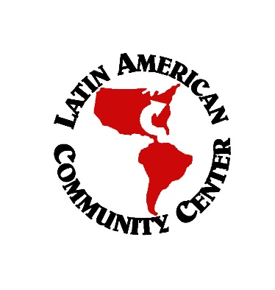Latin American Community Center

2025 Annual Grand Ball

*Casino Night*

Saturday September 27, 2025

Deerfield Golf Club

507 Thompson Station Rd

Newark, DE 19711

Program Advertising Opportunities

|  |  |
| --- | --- |
| **Advertising Level** | **Package** |
| $850 | (1) full page advertisement in event program  (2) tickets to the Grand Ball ($180 each) |
| $550 | (1) half page advertisement in event program  (2) tickets to the Grand Ball ($180 each) |
| $350 | (1) half page advertisement in event program |

Please make checks payable to: Latin American Community Center   
Credit card payments can be made online at thelatincenter.org/grandball

**LACC 2025 Annual Grand Ball Program Advertising Form**

Company/Organization: ________________________________________

Address: _____________________________________________________

Contact Name: ___________________________________________ Title: ____________________

Phone: ___________________________ Email: ________________________________

Please Select:

|  |  |  |
| --- | --- | --- |
| 🞏 1/2 page advertisement ($350) | 🞏 1/2 page advertisement & 2 tickets ($550) | 🞏 full page advertisement & 2 tickets ($850) |

All advertisements must be emailed to kscanlan@thelatincenter.org in PDF or PNG format by September 5, 2025

Kelly Scanlan, Director of Development and Communications Payment Method:   
Latin American Community Center 🞏 check enclosed   
403 N. Van Buren Street 🞏 credit card   
Wilmington, DE 19805  
302-655-7338 X 7734  
[kscanlan@thelatincenter.org](mailto:kscanlan@thelatincenter.org)